1. Title of the Project
Smart Blood Connect – A Web-Based Blood Donor Portal using Java and MySQL
2. Introduction
Blood has a critical role in medicine; every day somebody needs blood. Unfortunately, there are many medical emergencies where suitable blood donors are not available fast enough. In many areas, donor records are still recorded manually with registers and files, resulting in slow, time-consuming processes, difficulty with record management, and frustration for staff trying to locate and recruit blood donors.
Smart Blood Connect is a Web-based (Internet) blood donor registry portal written in the Java programming language (for back-end functionality) and MySQL database (to store data) that will provide quick and efficient access to blood donor records, blood type & group information, available donors based upon geographical location and blood type (for example) to any user visiting the site/addressed to an administrator at any time.
3. Objectives of Project
The primary objectives of this project are:
• Create a web-based blood donor registry portal (blood donor finder)
• Provide a Structured Database for Recording Blood Donor Information
• Facilitate Searching for Blood Donors Based on Geographical Location and Blood Type
• Reduce the Need for Manual Work and Save time
• Increase the Speed and Accuracy of Management of Blood Donor Records
• Provide a Simple User Interface for Both Admin and Visitor Users of the Blood Donor Registry Portal.
4. Problem Statement
Currently, the way blood donor information is managed is through manual processes which have shown to not be working as efficiently as they could. Some of the issues that both hospitals and blood banks find with today's donor management systems include:
• Finding a blood donor quickly during an emergency.
• Obtaining and maintaining blood donor records is extremely time-consuming and tedious.
• The risk of losing donor data because of using manual record keeping methods.
• There is no proper system or process in place to update donor information.
• The efficiency of the blood donor database is low, and the cost to maintain it is extremely high.
The purpose of this project is to provide a web-based solution (a portal) that provides an automated solution for managing blood donor information to all hospitals and blood banks.
5. Scope of the Project
The proposed system allows users to:
• Store blood donor-related information.
• Store blood type information for each blood donor.
• Search for blood donors by either their blood type or location.
• Provide an administrative panel that allows access to manage all of their blood donor/recipient data.
• Provide public access to the visitor/s to search for blood donors
This system will allow for the management of blood donors in hospitals, blood banks, non-governmental organizations (NGOs), and emergency medical service agencies.
6. Modules of the System
The system is made up of 2 modules:
1st Module: Admin Module
Administrators of the blood donor information will be able to:
• Add new blood donors to the system.
• Update blood donor information in the database.
• Remove blood donor information from the database.
• Manage and update the blood donor’s blood type in the database.
• Provide visibility for all blood donor information stored in the system.
• Manage requests made to view donor details submitted by visitors to the database.

2nd Module: Visitor Module
Visitors to the blood donor information will be able to:
• Search for all blood donors by blood type.
• Search for all blood donors by geographic location.
• View specific blood donor information.
• Register as a new blood donor in the blood donor information database.
7.Data Flow Diagram
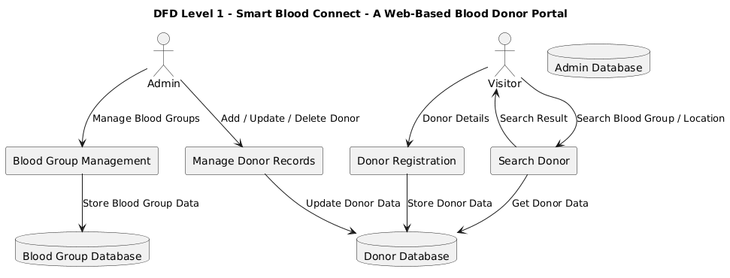
8. Technology Used
For Front-End
• HTML
• CSS
• JavaScript
For Back-End
• Java (JSP / Servlet)
At The Database Level
• MySQL
At The Software Tools Level
• Apache Tomcat Server
• MySQL Workbench
• Eclipse / NetBeans IDE
9. Description of System Requirements
At The Hardware Level
• 4 GB of RAM
• 500 GB Hard Disk
• An Intel i3 Processor or higher
At The Software Level
• Windows 10/Windows 11 Operating System
• Java JDK 8 (or higher)
• MySQL Server
• Apache Tomcat
• A Web Browser (Chrome or Edge)
10. Description of Methodology
The Following are the Steps Used in Building the System
1. Requirement Analysis
2. System Design and Development (Database Plus User Interface Design)
3. Coding in Java and the Database With MySQL
4. Testing the Completed System
5. Implementing the Completed System
6. Maintaining the Completed System
11. Description of What the System Will Do
• Search For Donors Quickly
• Track Donor Information Accurately
• Reduce Manpower Required to Manage Donor Information
• Give You More Time and Less Effort To Find Donors
• Create A Very User-Friendly Portal
12. Conclusion
Smart Blood Connect-A Web Based Solution For Blood Donors And Recipient Is A Great Product And Will Provide Benefits Like: Operator Error Reduction For Finding Donors; Standardized Workflows For Finding Donors; Faster Finding Donors Than Previously Possible; A More Convenient And Easy Way For Blood Donors And Recipients To Find Each Other; A More Efficient Way For Blood Donors And Recipients To Interact; A Single Centralized Application To Manage Blood Donor And Recipient Requests; All Of These Benefits Will Make Blood Donor & Recipient Process Much Easier To Use And Much Less Stressful & Time Consuming For Hospitals, Blood Banks & The General Public.

